Ideation Phase
Brainstorm & Idea Prioritization
Template
Date
Team Id | NM2025TMID02994
Project Name | Lease Management
Maximum Mark | 4 Mark

Prevent user deletion if assigned to an incident Template :

To prevent user deletion when assigned to an active incident in lease management, implement a check before proceeding with the deletion. The system should query the incident table to see if the user is linked to any active incidents. If they are, deletion should be blocked with an appropriate error message, such as "User cannot be deleted because they are assigned to an active incident." This prevents data integrity issues and ensures that the user cannot be removed while still involved in ongoing processes. The deletion logic should only proceed if the user is not assigned to any active incidents, helping to protect the system's workflow

Team Gathering, Collaboration and Select the Problem Statement: .

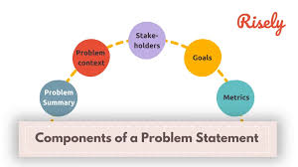

Brainstorm, Idea Listing and Grouping:

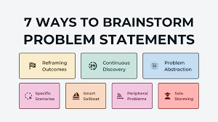

Image that describes the work done by teammates.

Brainstorm: Team members share ideas freely to explore solutions without judgment, encouraging creativity and participation.

Idea Listing: All ideas from the session are written down to capture every suggestion and ensure no input is overlooked.

Grouping: Similar ideas are organized into categories to identify patterns, highlight priorities, and simplify decision-making.

Action Planning: Chosen ideas are turned into clear steps with assigned responsibilities and timelines

Idea Prioritization:



Image of steps to prevent user deletion.

Idea Prioritization: Idea polarization helps break down complex projects into clear, focused components. In this project, the main goal is to prevent user deletion if the account is assigned to an active incident. This approach ensures that data integrity and accountability are maintained during critical workflows. By polarizing ideas, we can separate incident management processes from routine administrative tasks. It also helps in highlighting the importance of user account security and controlled access. Each step, from detection to restriction, becomes easier to plan and implement. Clear visual representations like diagrams and flowcharts can simplify communication. Overall, idea polarization strengthens project clarity and supports smooth execution.

